VISVESVARAYA TECHNOLOGICAL UNIVERSITY

“JnanaSangama”, Belgaum -590014, Karnataka.

LAB RECORD

Bio Inspired Systems (23CS5BSBIS)
Submitted by
SUSHMITHA KL (1WA23CS003)
in partial fulfillment for the award of the degree of

BACHELOR OF ENGINEERING
in
COMPUTER SCIENCE AND ENGINEERING



B.M.S. COLLEGE OF ENGINEERING
(Autonomous Institution under VTU)
BENGALURU-560019
Aug-2025 to Jan-2026

B.M.S. College of Engineering,
Bull Temple Road, Bangalore 560019
(Affiliated To Visvesvaraya Technological University, Belgaum)
Department of Computer Science and Engineering
CERTIFICATE
This is to certify that the Lab work entitled “ Bio Inspired Systems (23CS5BSBIS)” carried out by Sushmitha KL (1WA23CS003), who is bonafide student of B.M.S. College of Engineering. It is in partial fulfillment for the award of Bachelor of Engineering in Computer Science and Engineering of the Visvesvaraya Technological University, Belgaum. The Lab report has been approved as it satisfies the academic requirements of the above mentioned subject and the work prescribed for the said degree.

Sandhya A Kulkarni  Assistant Professor  Department of CSE, BMSCE | Dr. Kavitha Sooda  Professor & HOD  Department of CSE, BMSCE

Index
Sl.  No. | Date | Experiment Title | Page No.
1 | 28/8/25 | Genetic Algorithm | 4
2 | 11/9/25 | Particle Swarm Optimization | 10
3 | 9/10/25 | Ant Colony Optimization | 14
4 | 16/10/25 | Cuckoo Search Optimization | 19
5 | 6/11/25 | Grey Wolf Optimization | 23
6 | 13/11/25 | Parallel Cellular Algorithm | 27
7 | 28/8/25 | Gene Expression Algorithm | 30

Github Link: http://github.com/SushmithaKL01/BISLabs

Program 1

GENETIC ALGORITHM - A salesman must visit a given list of n-cities exactly once and return to the starting city. The distance between each pair of cities is known. The goal is to determine the shortest possible route that visits all cities.
Use Genetic Algorithm to find a near-optimal solution to the Travelling Salesman Problem by evolving candidate routes toward the minimum total travel distance.

Algorithm:

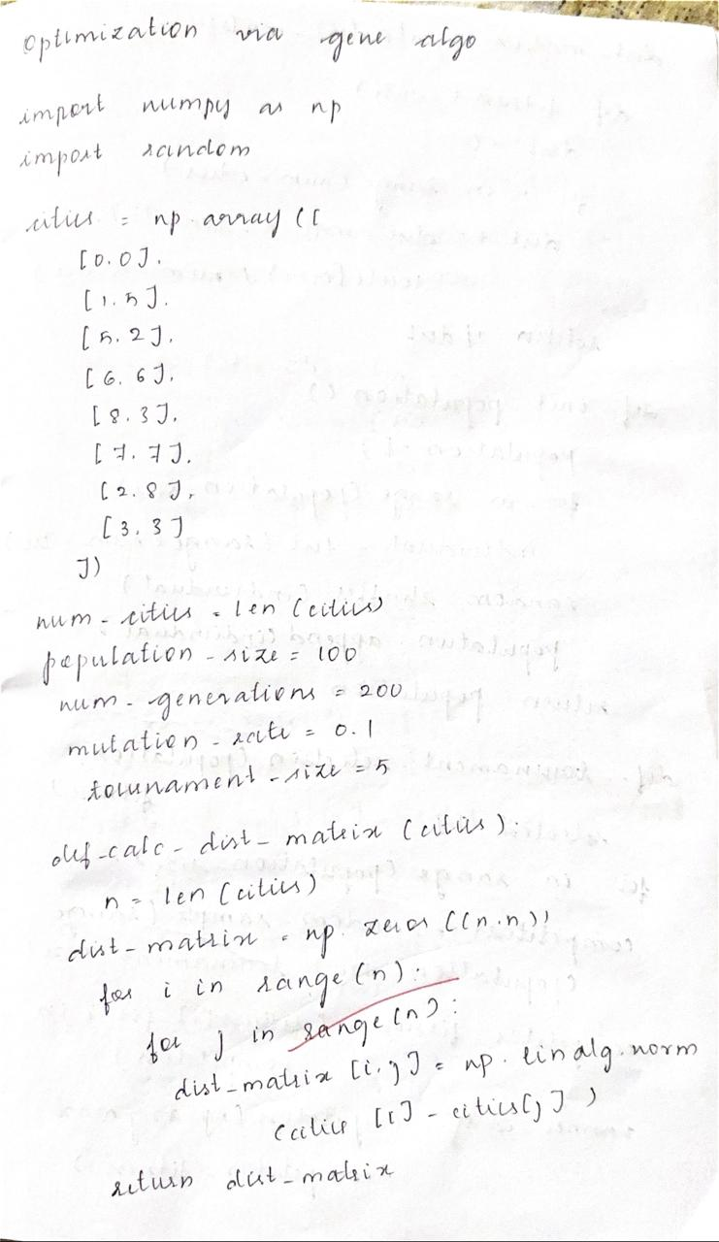

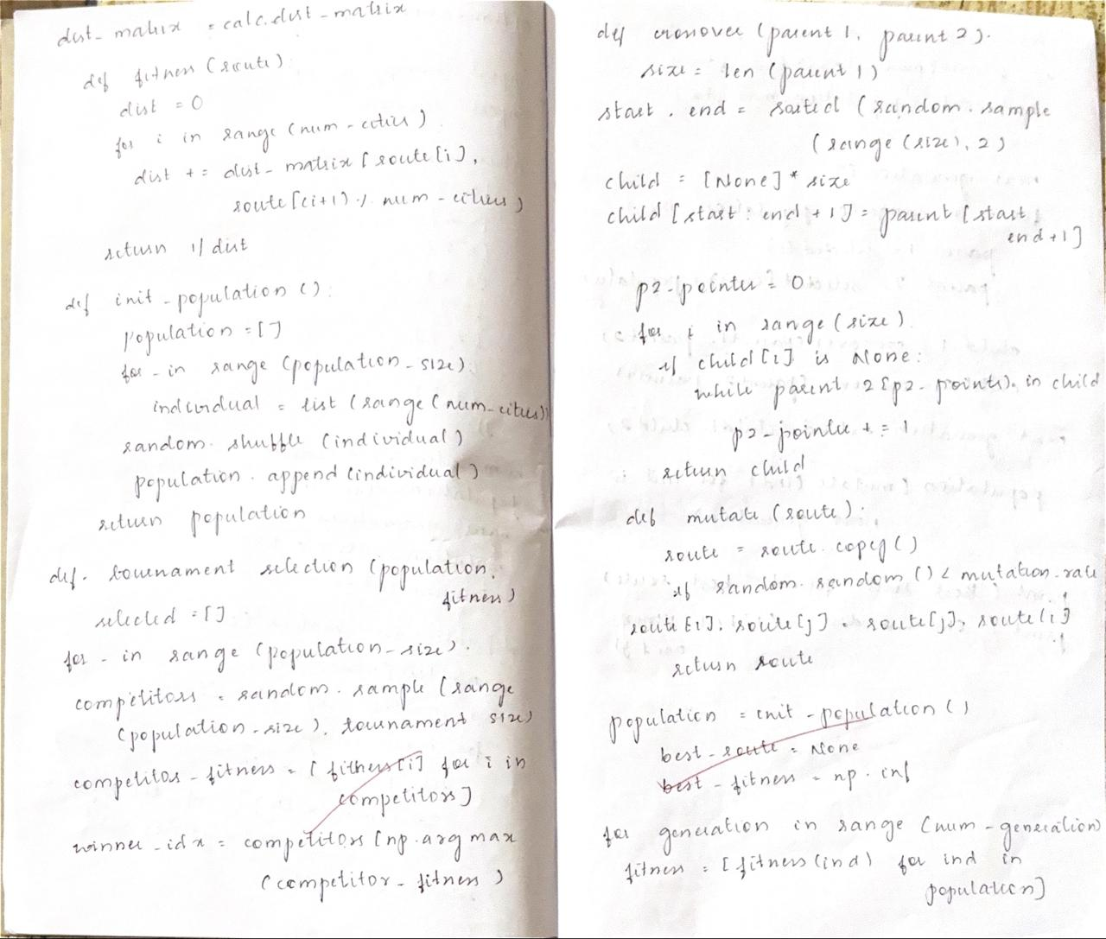
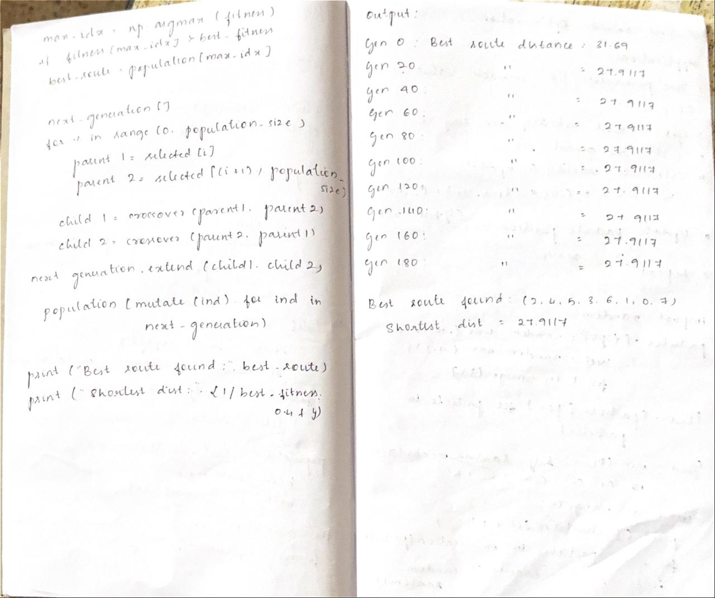

Code:

import random

# Parameters
POP_SIZE = 6
GENES = 5 # 5 bits to represent 0-31
GENERATIONS = 5
CROSSOVER_RATE = 0.7
MUTATION_RATE = 0.1

# Fitness function: f(x) = x^2
def fitness(binary_str):
x = int(binary_str, 2)
return x * x

# Create initial population of random 5-bit binary strings
def create_population():
population = []
for _ in range(POP_SIZE):
individual = ''.join(random.choice('01') for _ in range(GENES))
population.append(individual)
return population

# Selection: Tournament Selection of size 2
def tournament_selection(pop):
i1, i2 = random.sample(pop, 2)
return i1 if fitness(i1) > fitness(i2) else i2

# Crossover: Single-point crossover
def crossover(parent1, parent2):
if random.random() < CROSSOVER_RATE:
point = random.randint(1, GENES - 1)
child1 = parent1[:point] + parent2[point:]
child2 = parent2[:point] + parent1[point:]
return child1, child2
else:
return parent1, parent2

# Mutation: Bit flip mutation
def mutate(individual):
new_ind = ''
for bit in individual:
if random.random() < MUTATION_RATE:
new_ind += '1' if bit == '0' else '0'
else:
new_ind += bit
return new_ind

# Main GA function
def genetic_algorithm():
population = create_population()
best_individual = None
best_fitness = -1

for gen in range(1, GENERATIONS + 1):
new_population = []

# Evaluate and keep track of best
for ind in population:
ind_fit = fitness(ind)
if ind_fit > best_fitness:
best_fitness = ind_fit
best_individual = ind

# Print best in current generation
print(f"Generation {gen}: Best Individual = {best_individual} (x={int(best_individual, 2)}), Fitness = {best_fitness}")

# Create new generation
while len(new_population) < POP_SIZE:
parent1 = tournament_selection(population)
parent2 = tournament_selection(population)
child1, child2 = crossover(parent1, parent2)
child1 = mutate(child1)
child2 = mutate(child2)
new_population.extend([child1, child2])

population = new_population[:POP_SIZE]

print(f"\nBest solution found: {best_individual} (x={int(best_individual, 2)}), Fitness = {best_fitness}")

if __name__ == "__main__":
genetic_algorithm()

Output:

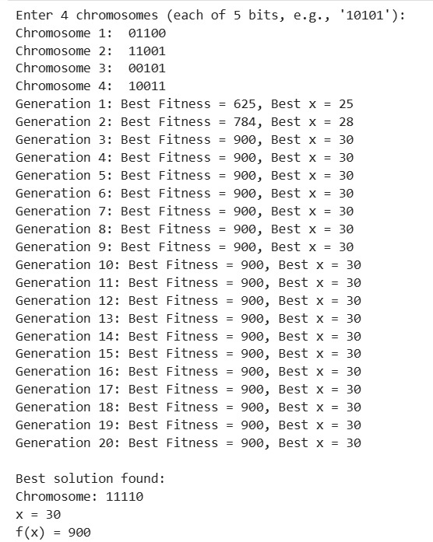

Program 2

PARTICLE SWARM OPTIMIZATION - Training a neural network involves finding an optimal set of weights and biases that minimize prediction error. Traditional gradient-based optimization methods.
Use Particle Swarm Optimization to optimize the weights and biases of a neural network by treating each particle as a potential weight vector and iteratively updating their positions to minimize the network’s loss function.

Algorithm:

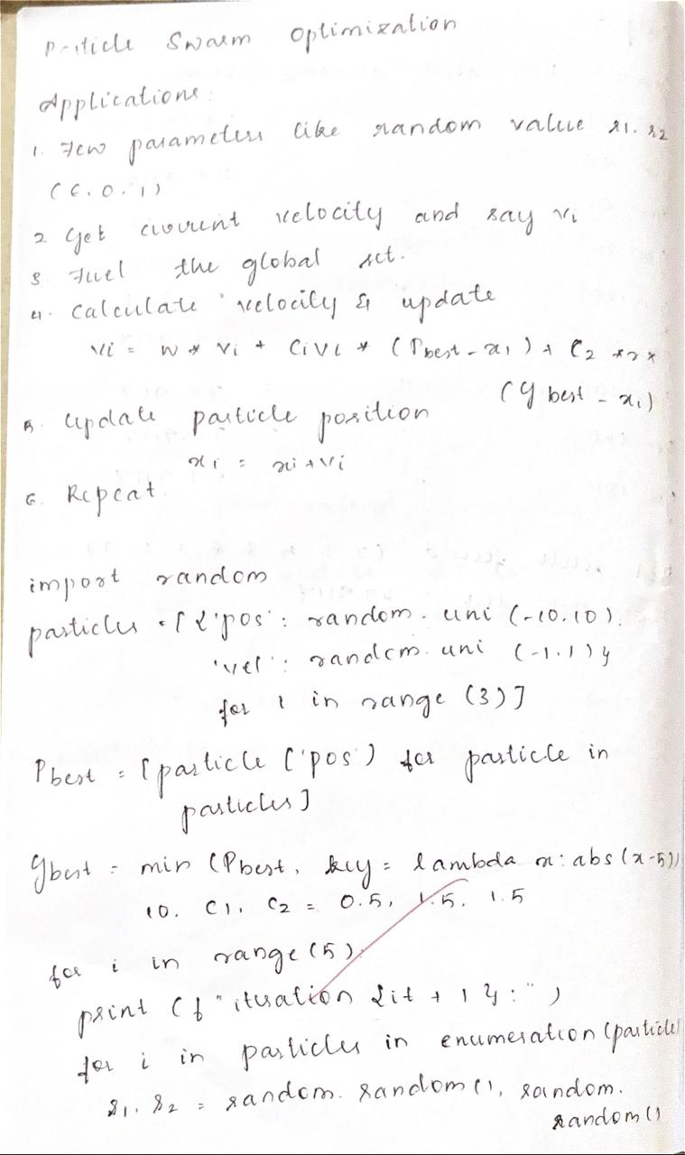

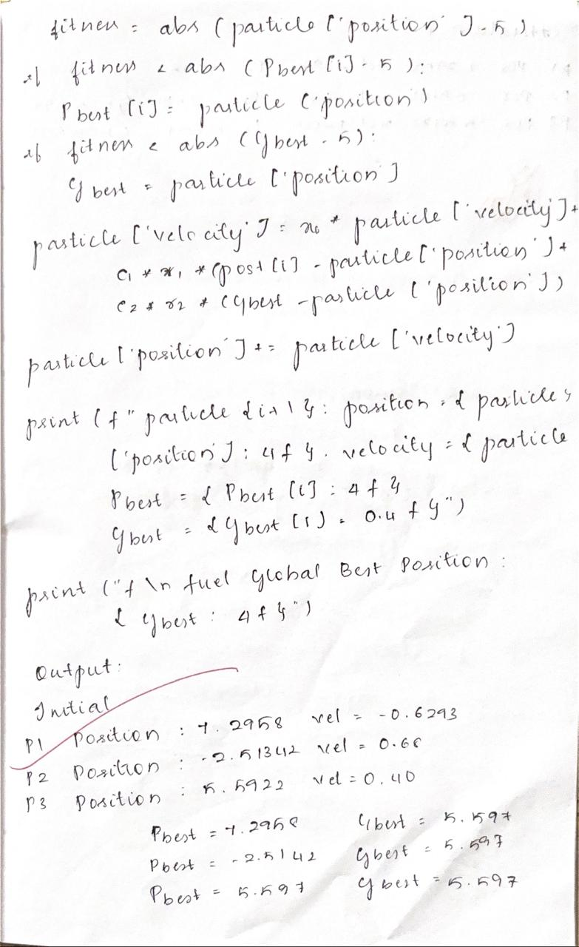

Code:

import random

def fitness_function(position):
x, y = position
return x**2 + y**2

num_particles = 10
num_iterations = 50
W = 0.3
C1 = 2
C2 = 2

particles = [[random.uniform(-10, 10), random.uniform(-10, 10)] for _ in range(num_particles)]
velocities = [[0.0, 0.0] for _ in range(num_particles)]

pbest_positions = [p[:] for p in particles]
pbest_values = [fitness_function(p) for p in particles]

gbest_index = pbest_values.index(min(pbest_values))
gbest_position = pbest_positions[gbest_index][:]
gbest_value = pbest_values[gbest_index]

for iteration in range(num_iterations):
for i in range(num_particles):
r1, r2 = random.random(), random.random()

velocities[i][0] = (W * velocities[i][0] +
C1 * r1 * (pbest_positions[i][0] - particles[i][0]) +
C2 * r2 * (gbest_position[0] - particles[i][0]))
velocities[i][1] = (W * velocities[i][1] +
C1 * r1 * (pbest_positions[i][1] - particles[i][1]) +
C2 * r2 * (gbest_position[1] - particles[i][1]))

particles[i][0] += velocities[i][0]
particles[i][1] += velocities[i][1]

current_value = fitness_function(particles[i])

if current_value < pbest_values[i]:
pbest_positions[i] = particles[i][:]
pbest_values[i] = current_value

if current_value < gbest_value:
gbest_value = current_value
gbest_position = particles[i][:]

print(f"Iteration {iteration+1}/{num_iterations} | Best Value: {gbest_value:.6f} at {gbest_position}")

print("\nOptimal Solution Found:")
print(f"Best Position: {gbest_position}")
print(f"Minimum Value: {gbest_value}")

Output:

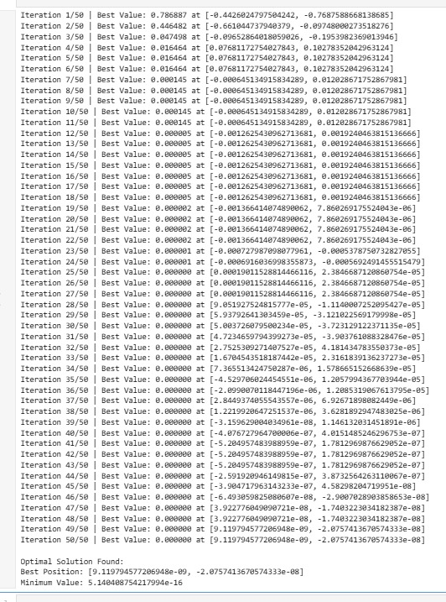

Program 3

ANT COLONY OPTIMIZATION - In a communication network, data packets must be routed from a source node to a destination node through multiple possible paths. As the network grows larger and more dynamic, finding the shortest and least congested path becomes increasingly complex for traditional deterministic routing algorithms.
Use Ant Colony Optimization to compute the optimal or near-optimal routing path between nodes in a network

Algorithm:

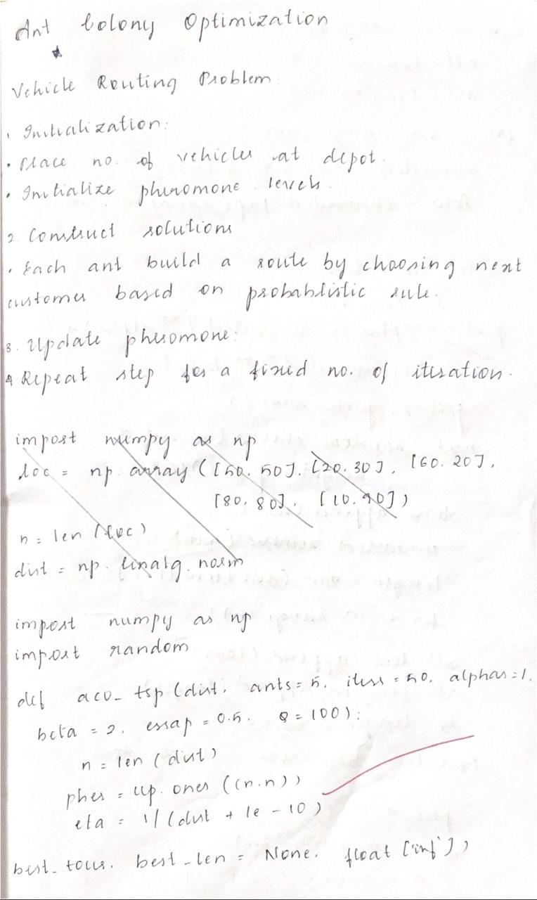

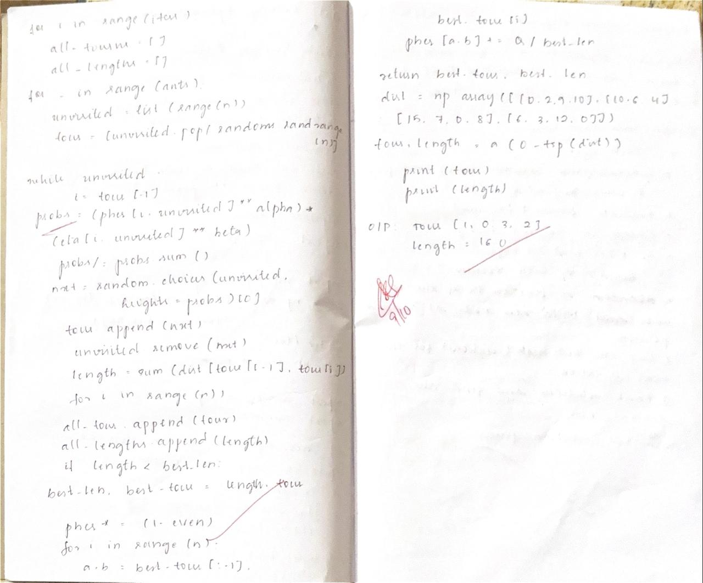

Code:

import numpy as np
import random

class ACO_TSP:
def __init__(self, distances, n_ants=10, n_iterations=50, alpha=1, beta=3, rho=0.5, Q=100):
self.distances = distances
self.num_cities = distances.shape[0]
self.n_ants = n_ants
self.n_iterations = n_iterations
self.alpha = alpha
self.beta = beta
self.rho = rho
self.Q = Q
self.pheromone = np.ones((self.num_cities, self.num_cities))
self.visibility = 1 / (distances + np.eye(self.num_cities))

def run(self):
best_distance = np.inf
best_tour = None

for iteration in range(self.n_iterations):
all_tours = []
all_distances = []

for _ in range(self.n_ants):
tour = self.construct_tour()
distance = self.calculate_distance(tour)
all_tours.append(tour)
all_distances.append(distance)

self.update_pheromones(all_tours, all_distances)

min_distance = min(all_distances)
if min_distance < best_distance:
best_distance = min_distance
best_tour = all_tours[np.argmin(all_distances)]

print(f"Iteration {iteration+1}: Shortest Distance = {min_distance:.2f}")

print("\nBest Tour:", best_tour)
print("Shortest Distance Found:", best_distance)
return best_tour, best_distance

def construct_tour(self):
start = random.randint(0, self.num_cities - 1)
tour = [start]
visited = set(tour)

for _ in range(self.num_cities - 1):
current = tour[-1]
next_city = self.select_next_city(current, visited)
tour.append(next_city)
visited.add(next_city)

tour.append(tour[0])
return tour

def select_next_city(self, current, visited):
probabilities = []
pheromone = np.copy(self.pheromone[current])
visibility = np.copy(self.visibility[current])

for city in range(self.num_cities):
if city not in visited:
probabilities.append((pheromone[city] ** self.alpha) * (visibility[city] ** self.beta))
else:
probabilities.append(0)

probabilities = np.array(probabilities)
probabilities = probabilities / probabilities.sum()
return np.random.choice(range(self.num_cities), p=probabilities)

def calculate_distance(self, tour):
distance = 0
for i in range(len(tour) - 1):
distance += self.distances[tour[i], tour[i+1]]
return distance

def update_pheromones(self, all_tours, all_distances):
self.pheromone *= (1 - self.rho)
for tour, dist in zip(all_tours, all_distances):
for i in range(len(tour) - 1):
self.pheromone[tour[i], tour[i+1]] += self.Q / dist

if __name__ == "__main__":
distance_matrix = np.array([
[0, 2, 9, 10, 7, 3],
[2, 0, 6, 4, 3, 8],
[9, 6, 0, 5, 2, 7],
[10, 4, 5, 0, 6, 4],
[7, 3, 2, 6, 0, 5],
[3, 8, 7, 4, 5, 0]
])

aco = ACO_TSP(distance_matrix, n_ants=8, n_iterations=20, alpha=1, beta=3, rho=0.4)
best_tour, best_distance = aco.run()

Output:

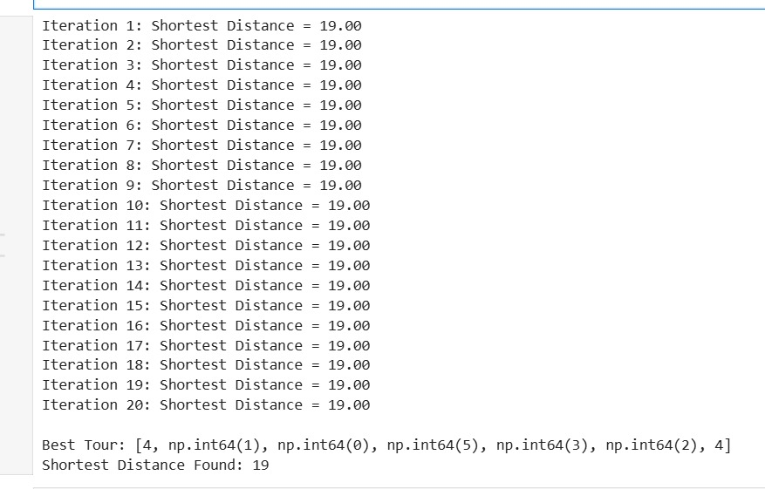

Program 4

CUCKOO SEARCH OPTIMIZATION – Many engineering design problems, such as designing a spring, a gear system, or a pressure vessel, require determining a set of parameters that minimize cost while satisfying mechanical, safety, and performance constraints.
Use Cuckoo Search Optimization to determine the optimal design parameters for an engineering system

Algorithm:

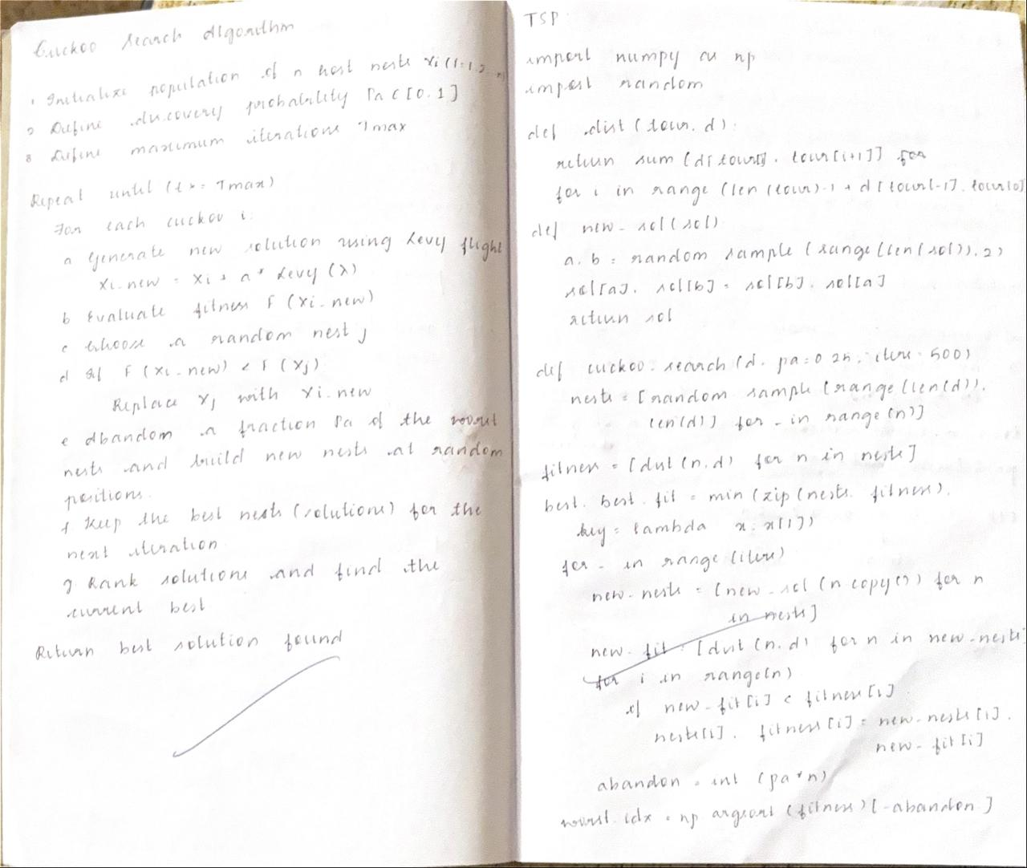

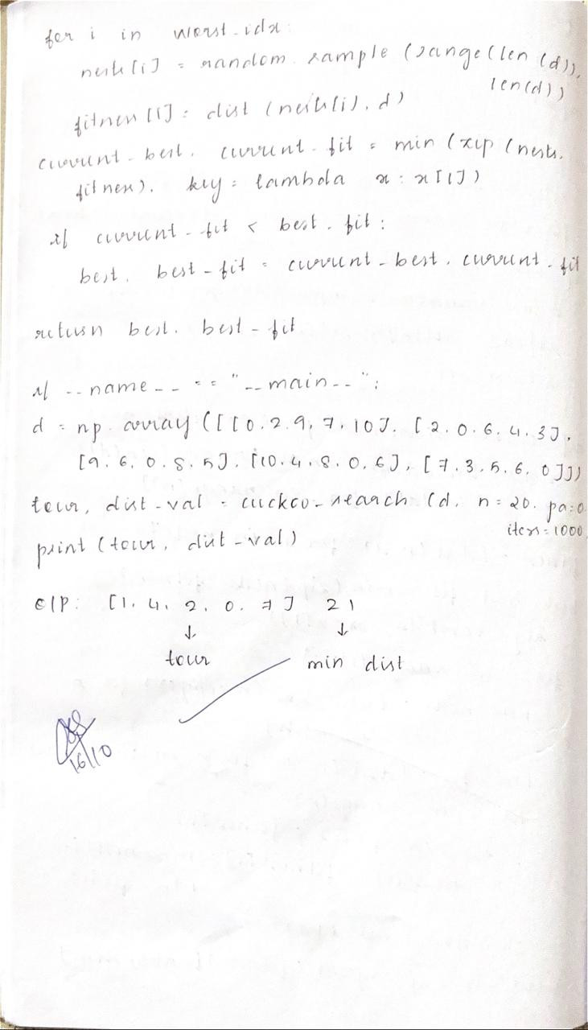
Code:

import numpy as np
import math

def objective_function(x):
return np.sum(x**2)

def initialize_nests(num_nests, dim, lower_bound, upper_bound):
return np.random.uniform(lower_bound, upper_bound, size=(num_nests, dim))

def levy_flight(Lambda, size):
sigma = (math.gamma(1 + Lambda) * math.sin(math.pi * Lambda / 2) /
(math.gamma((1 + Lambda) / 2) * Lambda * 2**((Lambda - 1) / 2))) ** (1 / Lambda)
u = np.random.randn(*size) * sigma
v = np.random.randn(*size)
step = u / np.abs(v) ** (1 / Lambda)
return step

def cuckoo_search(num_nests=25, dim=2, lower_bound=-10, upper_bound=10,
pa=0.25, max_iter=100):

nests = initialize_nests(num_nests, dim, lower_bound, upper_bound)
fitness = np.apply_along_axis(objective_function, 1, nests)

best_nest = nests[np.argmin(fitness)].copy()
best_fitness = np.min(fitness)

for t in range(max_iter):
new_nests = nests + 0.01 * levy_flight(1.5, nests.shape) * (nests - best_nest)
new_nests = np.clip(new_nests, lower_bound, upper_bound)

new_fitness = np.apply_along_axis(objective_function, 1, new_nests)

mask = new_fitness < fitness
nests[mask] = new_nests[mask]
fitness[mask] = new_fitness[mask]

rand = np.random.rand(num_nests, dim)
new_nests = np.where(rand > pa, nests,
initialize_nests(num_nests, dim, lower_bound, upper_bound))

new_fitness = np.apply_along_axis(objective_function, 1, new_nests)
mask = new_fitness < fitness
nests[mask] = new_nests[mask]
fitness[mask] = new_fitness[mask]

if np.min(fitness) < best_fitness:
best_nest = nests[np.argmin(fitness)].copy()
best_fitness = np.min(fitness)

print(f"Iteration {t+1}/{max_iter} | Best Fitness: {best_fitness:.6f}")

return best_nest, best_fitness

best_solution, best_value = cuckoo_search()
print("\nBest solution found:", best_solution)
print("Best fitness value:", best_value)

Output:

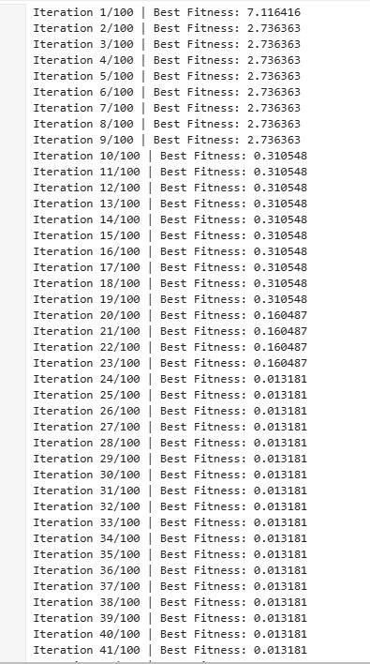
Program 5

GREY WOLF OPTIMIZATION - Support Vector Machines (SVMs) require optimal selection of hyperparameters—such as the regularization parameter $C$, kernel parameter $γ$, and kernel type—to achieve high classification accuracy.
Use Grey Wolf Optimization to automatically determine the optimal SVM hyperparameters by modelling each wolf as a candidate solution in the $(C,γ)$search space. The wolves will follow the leadership hierarchy (alpha, beta, delta) and encircling–hunting behavior to explore and exploit the parameter space.

Algorithm:

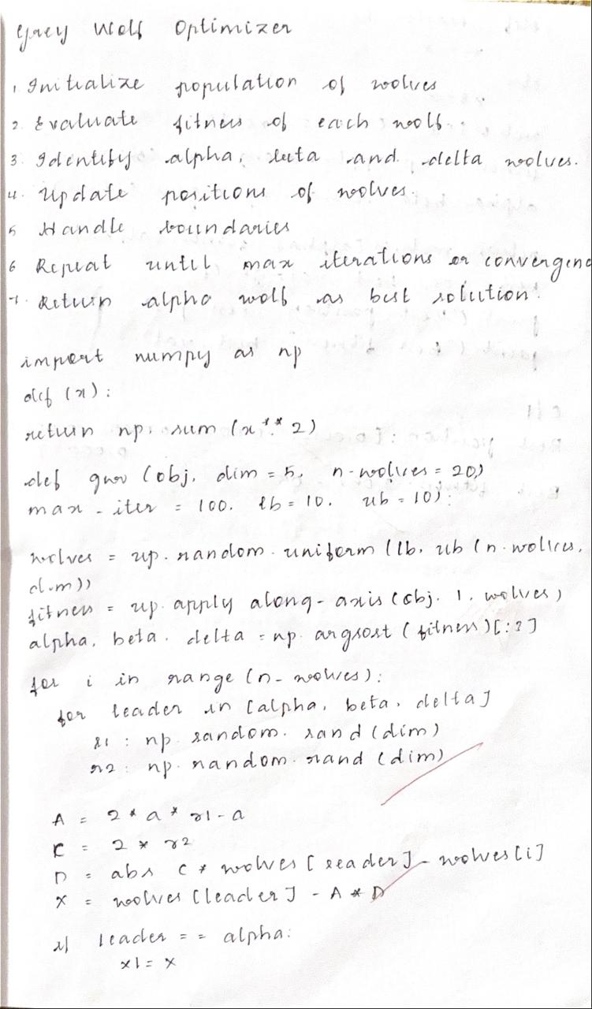

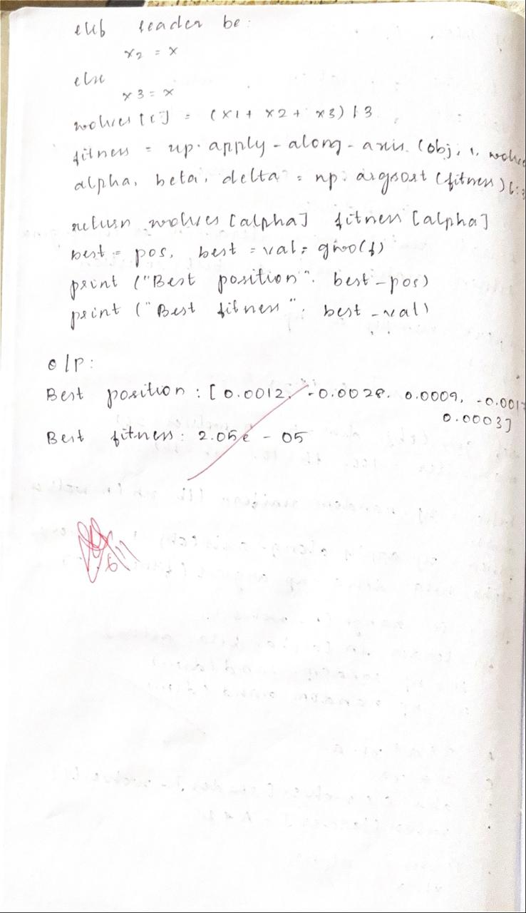
Code:

import numpy as np

def objective_function(x):
return np.sum(x**2)

def grey_wolf_optimizer(num_wolves=30, dim=2, max_iter=50, lower_bound=-10, upper_bound=10):
wolves = np.random.uniform(lower_bound, upper_bound, (num_wolves, dim))

Alpha_pos = np.zeros(dim)
Beta_pos = np.zeros(dim)
Delta_pos = np.zeros(dim)

Alpha_score = float("inf")
Beta_score = float("inf")
Delta_score = float("inf")

for t in range(max_iter):
for i in range(num_wolves):
wolves[i] = np.clip(wolves[i], lower_bound, upper_bound)
fitness = objective_function(wolves[i])

if fitness < Alpha_score:
Delta_score = Beta_score
Delta_pos = Beta_pos.copy()
Beta_score = Alpha_score
Beta_pos = Alpha_pos.copy()
Alpha_score = fitness
Alpha_pos = wolves[i].copy()
elif fitness < Beta_score:
Delta_score = Beta_score
Delta_pos = Beta_pos.copy()
Beta_score = fitness
Beta_pos = wolves[i].copy()
elif fitness < Delta_score:
Delta_score = fitness
Delta_pos = wolves[i].copy()

a = 2 - t * (2 / max_iter)

for i in range(num_wolves):
for j in range(dim):
r1 = np.random.rand()
r2 = np.random.rand()

A1 = 2 * a * r1 - a
C1 = 2 * r2
D_alpha = abs(C1 * Alpha_pos[j] - wolves[i][j])
X1 = Alpha_pos[j] - A1 * D_alpha

r1 = np.random.rand()
r2 = np.random.rand()
A2 = 2 * a * r1 - a
C2 = 2 * r2
D_beta = abs(C2 * Beta_pos[j] - wolves[i][j])
X2 = Beta_pos[j] - A2 * D_beta

r1 = np.random.rand()
r2 = np.random.rand()
A3 = 2 * a * r1 - a
C3 = 2 * r2
D_delta = abs(C3 * Delta_pos[j] - wolves[i][j])
X3 = Delta_pos[j] - A3 * D_delta

wolves[i][j] = (X1 + X2 + X3) / 3

print(f"Iteration {t+1}/{max_iter} | Best Fitness: {Alpha_score:.6f}")

return Alpha_pos, Alpha_score
best_position, best_score = grey_wolf_optimizer()
print("\nBest solution found:", best_position)
print("Best fitness value:", best_score)

Output:

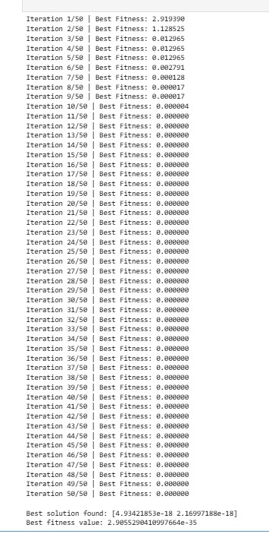

Program 6

PARALLEL CELLULAR ALGORITHM - Modern communication networks require routing algorithms that can adapt quickly to changes in traffic load, link failures, and congestion. Traditional centralized routing strategies may suffer from slow updates, high computational cost, and poor scalability as network size increases.
Use a Parallel Cellular Algorithm to compute optimal routing paths in a dynamic communication network. Each cell in the cellular grid represents a router or network node and updates its routing information based on local interactions with neighbouring cells.

Algorithm:

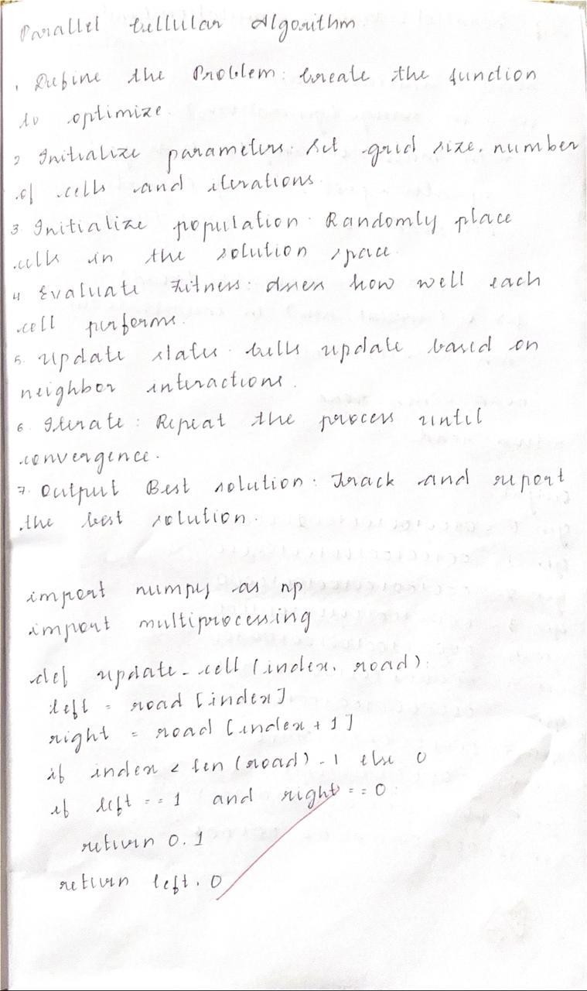
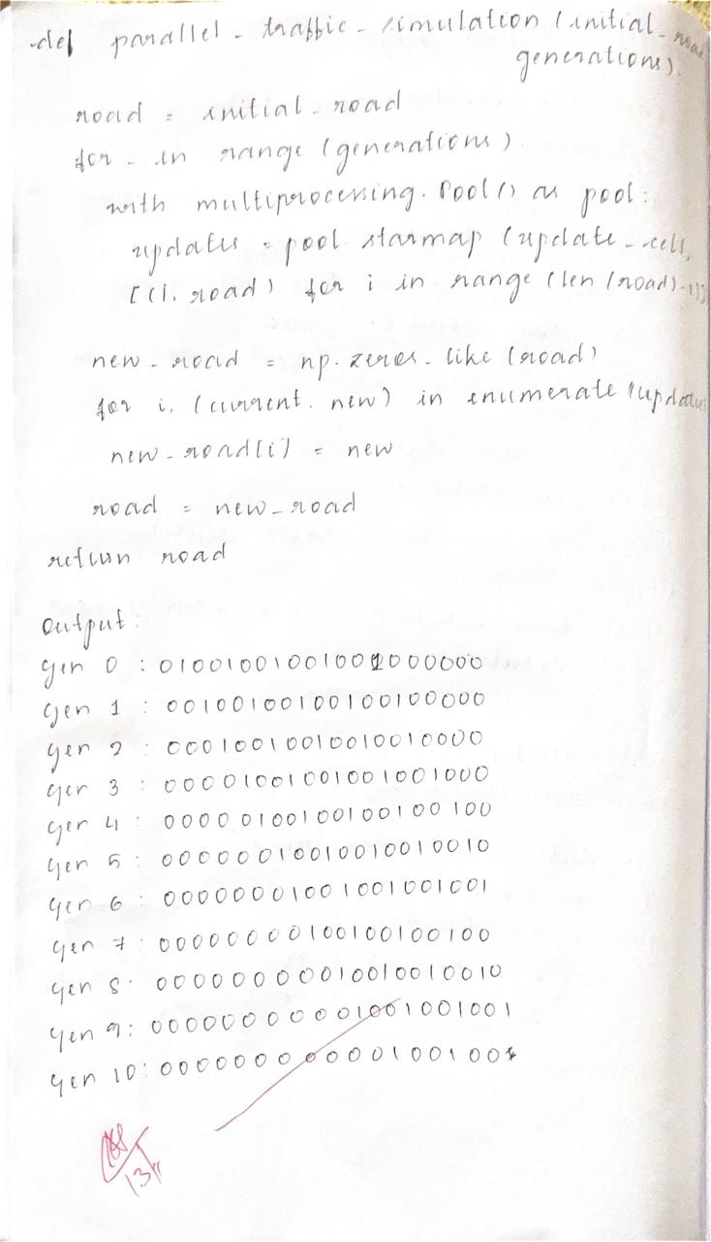
Code:

import numpy as np

GRID_SIZE = 5
MAX_ITER = 100
INF = 1e9

source = (0, 0)
destination = (4, 4)

np.random.seed(42)
cost_matrix = np.random.randint(1, 10, size=(GRID_SIZE, GRID_SIZE))

state = np.full((GRID_SIZE, GRID_SIZE), INF)
state[destination] = 0

neighbors = [(-1, 0), (1, 0), (0, -1), (0, 1)]

def get_neighbors(i, j):
"""Return valid neighboring cells"""
valid_neighbors = []
for dx, dy in neighbors:
ni, nj = i + dx, j + dy
if 0 <= ni < GRID_SIZE and 0 <= nj < GRID_SIZE:
valid_neighbors.append((ni, nj))
return valid_neighbors

for iteration in range(MAX_ITER):
new_state = state.copy()
for i in range(GRID_SIZE):
for j in range(GRID_SIZE):
if (i, j) == destination:
continue
neighbor_costs = []
for ni, nj in get_neighbors(i, j):
total_cost = cost_matrix[ni, nj] + state[ni, nj]
neighbor_costs.append(total_cost)
if neighbor_costs:
new_state[i, j] = min(neighbor_costs)
if np.allclose(new_state, state):
print(f"Converged after {iteration} iterations.")
break
state = new_state

path = [source]
current = source
while current != destination:
i, j = current
nbs = get_neighbors(i, j)
next_cell = min(nbs, key=lambda n: state[n])
path.append(next_cell)
current = next_cell

print("Final Routing Cost Grid:")
print(np.round(state, 2))
print("\nShortest Path from Source to Destination:")
print(" → ".join([str(p) for p in path]))
print(f"\nTotal Path Cost: {state[source]}")

Output:

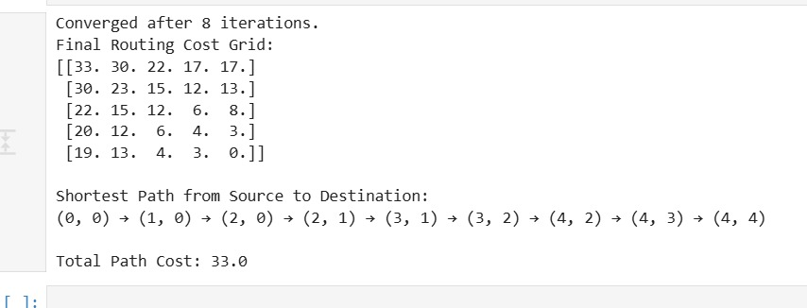

Program 7

GENE EXPRESSION ALGORITHM - Machine learning models often perform poorly when the original input features do not sufficiently capture the underlying patterns in the data. Manually engineering new features is time-consuming and requires domain expertise.
Use the Gene Expression and Evaluation Algorithm to automatically construct new features from existing input variables for a supervised learning task.

Algorithm:

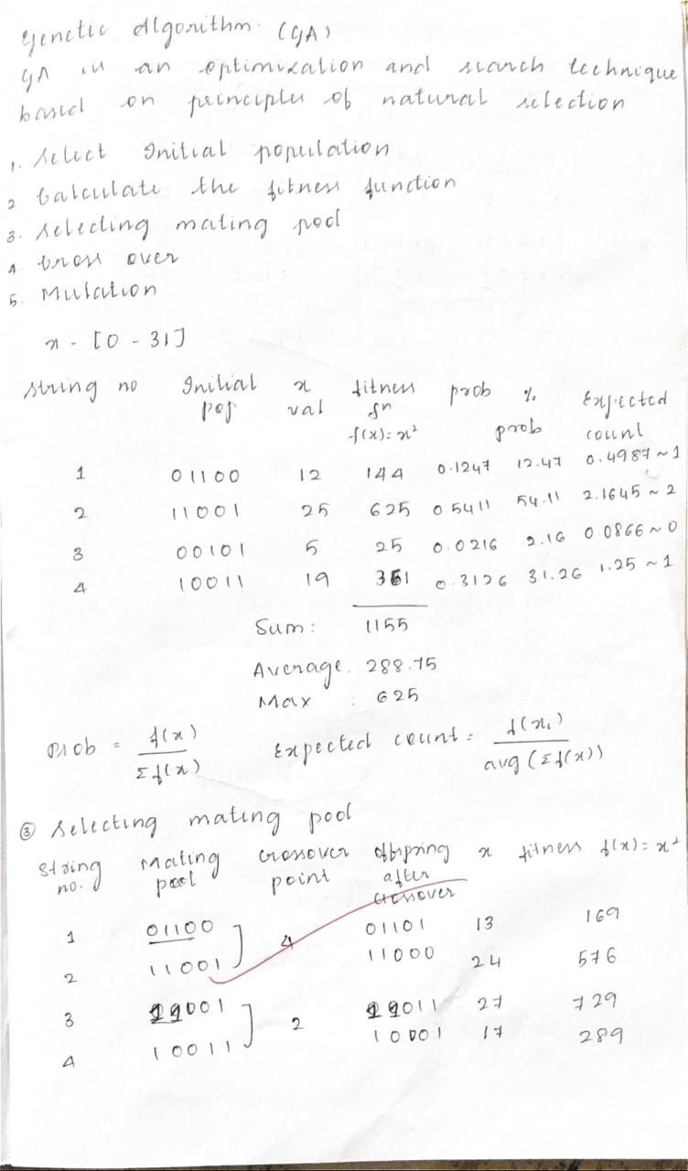

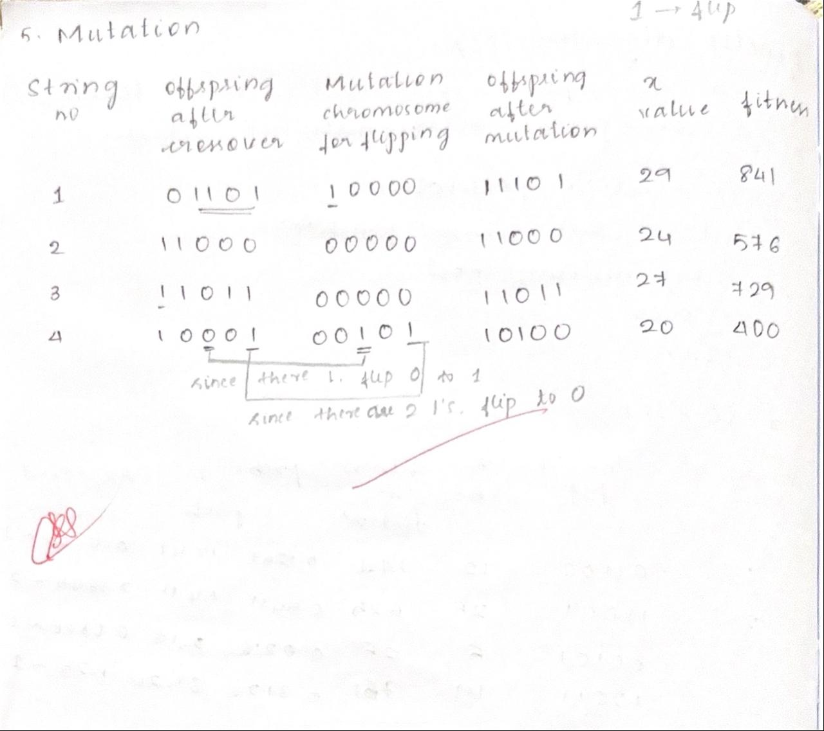

Code:

import random
import math

def fitness_function(x):
return x * math.sin(10 * math.pi * x) + 2

POPULATION_SIZE = 6
GENE_LENGTH = 10
MUTATION_RATE = 0.05
CROSSOVER_RATE = 0.8
GENERATIONS = 20
DOMAIN = (-1, 2)

def random_gene():
return random.uniform(DOMAIN[0], DOMAIN[1])

def create_chromosome():
return [random_gene() for _ in range(GENE_LENGTH)]

def initialize_population(size):
return [create_chromosome() for _ in range(size)]

def evaluate_population(population):
return [fitness_function(express_gene(chrom)) for chrom in population]

def express_gene(chromosome):
return sum(chromosome) / len(chromosome)

def select(population, fitnesses):
total_fitness = sum(fitnesses)
pick = random.uniform(0, total_fitness)
current = 0
for individual, fitness in zip(population, fitnesses):
current += fitness
if current > pick:
return individual
return random.choice(population)

def crossover(parent1, parent2):
if random.random() < CROSSOVER_RATE:
point = random.randint(1, GENE_LENGTH - 1)
child1 = parent1[:point] + parent2[point:]
child2 = parent2[:point] + parent1[point:]
return child1, child2
return parent1[:], parent2[:]

def mutate(chromosome):
new_chromosome = []
for gene in chromosome:
if random.random() < MUTATION_RATE:
new_chromosome.append(random_gene())
else:
new_chromosome.append(gene)
return new_chromosome

def gene_expression_algorithm():
population = initialize_population(POPULATION_SIZE)
best_solution = None
best_fitness = float("-inf")

for generation in range(GENERATIONS):
fitnesses = evaluate_population(population)

for i, chrom in enumerate(population):
if fitnesses[i] > best_fitness:
best_fitness = fitnesses[i]
best_solution = chrom[:]

print(f"Generation {generation+1}: Best Fitness = {best_fitness:.4f}, Best x = {express_gene(best_solution):.4f}")

new_population = []
while len(new_population) < POPULATION_SIZE:
parent1 = select(population, fitnesses)
parent2 = select(population, fitnesses)
offspring1, offspring2 = crossover(parent1, parent2)
offspring1 = mutate(offspring1)
offspring2 = mutate(offspring2)
new_population.extend([offspring1, offspring2])

population = new_population[:POPULATION_SIZE]

print("\nBest solution found:")
print(f"Genes: {best_solution}")
x_value = express_gene(best_solution)
print(f"x = {x_value:.4f}")
print(f"f(x) = {fitness_function(x_value):.4f}")

if __name__ == "__main__":
gene_expression_algorithm()

Output:

